

National University of Computer and Emerging Sciences



Smart House System

**Team Members**

Abdul Rehman ………… 19L-1135

Ammar Nadeem ………… 19L-0911

Rohail Kamran ………… 19L-0941

**Section:**

Internet of Things

(BCS-8A & BCS-8B)

**Instructor:**

**Arshad Ali**

*Abstract*

The main objective of this project is to develop a home power management system using an Arduino board with Bluetooth/WIFI to be remotely controlled by any Android OS smartphone. With the advancement of technology, houses are also getting smarter. Presently, conventional wall switches in different parts of the house make it difficult to go near them to operate, which is even more challenging for the elderly or physically disabled people to do so. The remote-controlled home power management system provides most modem solutions with smartphones. To achieve this, a Bluetooth/WIFI module is interfaced with the Arduino board at the receiver end. On the transmitter end, a GUI application on the cell phone sends ON/OFF commands to the receiver where loads are connected. By touching the specified location on the GUI, the loads can be turned ON/OFF remotely through this technology. The loads are operated by Arduino board through mechanical Relays.

*Introduction*

In today's era, we have remote controls for our television sets and other electronic systems, making our lives easy. But we do not have this faculty for our homes that are both cost-friendly and effective. We aim to create a new system called Arduino-based Smart House System using Bluetooth/WIFI, that will give the user, the ability to control any electronic switch/appliances in their house using his/her smartphone.

*Problem Statement*

Smart House System refers to controlling the home switches by using computer technology. Computer Systems enable remote control of electrical switches through complex micro-controller or computer-based networks with varying degrees of intelligence and automation. Smart House System provides security, energy efficiency and ease of use, which is why it is being adopted more. It also provides a remote interface to home appliances to provide control and monitoring on a web browser.

*Objectives / Goals*

The different controllable appliances must be interconnected and communicate with each other. The basic aim of the Smart House System is to control or monitor signals from different appliances, or basic services. A smartphone or web browser can be used to control or monitor the Smart House System. The main focus is to:

* To turn different switches of different rooms ON/OFF remotely
* Set schedules to save/divert power in case of low voltage from the main grid
* Have record of all the house power consumption and billings
* In case of voltage fluctuation, disconnect the house switches from the main grid until the fluctuation turns stable

*Components required*

The Hardware required in the development of the Smart House System are:

* ESP32

ESP32 is a series of low-cost, low-power system on a chip microcontroller with integrated Wi-Fi and dual-mode Bluetooth

* Arduino UNO

Arduino UNO is a microcontroller board based on the ATmega328P. It has 14 digital input/output pins (of which 6 can be used as PWM outputs), 6 analog inputs, a 16 MHz ceramic resonator, a USB connection, a power jack, an ICSP header and a reset button.

* CT- Talema AC1030

A Current Transformer (CT) is used to measure the current of another circuit. CTs are used worldwide to monitor high-voltage lines across national power grids. A CT is designed to produce an alternating current in its secondary winding that is proportional to the current that it is measuring in its primary.

* Other Accessories

Wires, Bulbs, Bread Board, Resistors, Capacitors, Switches

*Cloud Configuration & Experimental Results*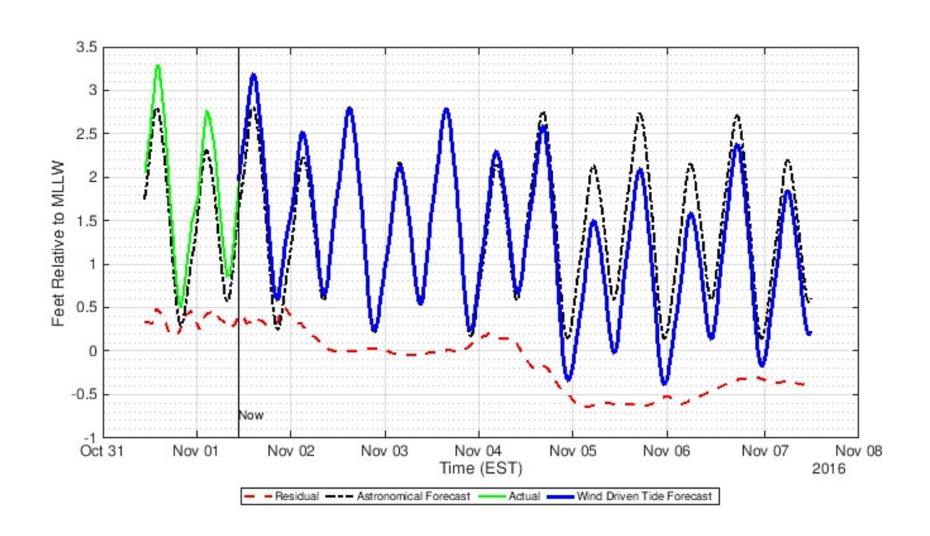

*Analysis*

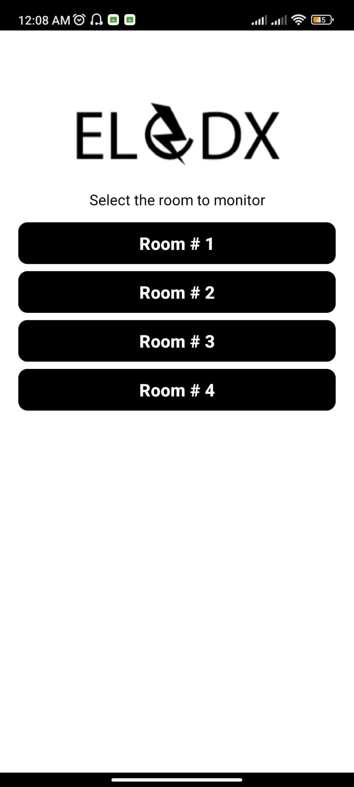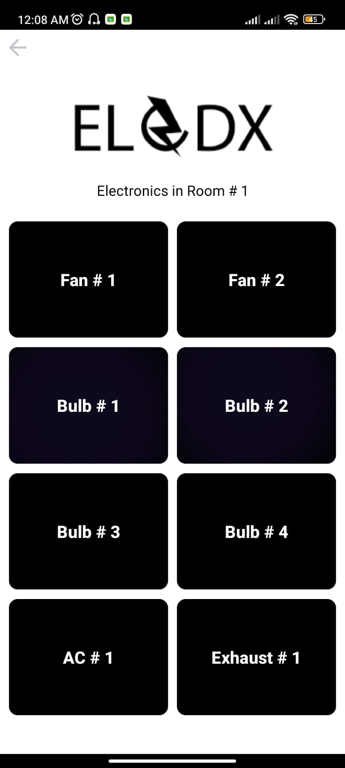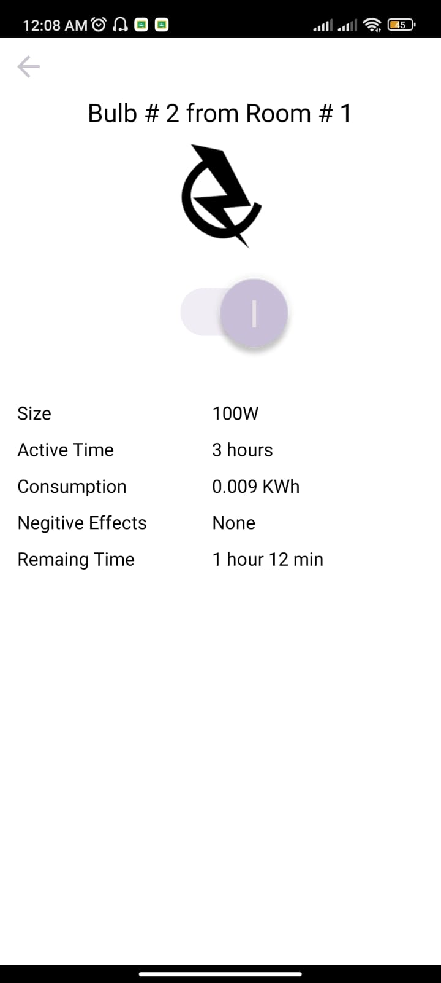

*Conclusion*

Smart Home Monitoring System is widely used in the market and we will further improve our product. Overall, it has been a great learning experience for us and we will further venture into this field in our professional lives.

*References*

1. Smart Home Monitoring System Using ESP32 Microcontrollers [Online].

Available: https://www.intechopen.com/chapters/74005

1. Design and Implementation of a Real-Time Smart Home Management System Considering Energy Saving [Online].

Available: https://www.mdpi.com/2071-1050/14/21/13840